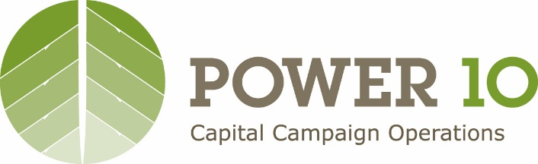

Investor Relations Communications During Coronavirus Pandemic
We have been impressed – particularly in the past couple of weeks - by the work of our clients to serve as thought leaders, advocates, and problem solvers for their investors and other stakeholders. Economic developers can be the “first responders” to the business community during this challenging time, and we encourage you to continue doing so.
We recommend that, in addition to standard membership / stakeholder communications, our clients communicate proactively and regularly with investors during this national crisis and future recovery. In particular, we recommend making a personal phone call to investors and sending a communication to them covering some / all of the following [items in yellow are to be tailored]:

We are grateful for your continued work for and investment in the [organization’s work / initiative]. Because of your investment in [Organization Name] we have been well positioned to lead our business community during this challenging time. A few examples of our Coronavirus response efforts include [customize examples]:
- Diversion of funds that would have been spent on events / travel during this period of months to projects designed to directly alleviate the effects of the pandemic on the business community such as ____
- Provision of information / resources to stakeholders
- Collaboration with state chamber / EDO and elected officials
In light of the current challenges, we are flexibly adapting our program of work in our [initiative / five year plan of work], and will engage and update you as our plans are finalized. We want to respond quickly and effectively to these challenging times and trust that, in partnership with you, our community will emerge even stronger.
Although most of our team members are working remotely, we are “open for business.” In the coming days, we will be contacting you by phone to check in and see how your business is faring. We understand that these are trying times for many, and we are here to help.

